CS 255 DriverPass System Design

UML Diagrams

UML Use Case Diagram
The use case diagram shows the primary DriverPass users and the system functions available to each role. It includes customers, secretaries, instructors, management, IT administrators, and the external DMV system.
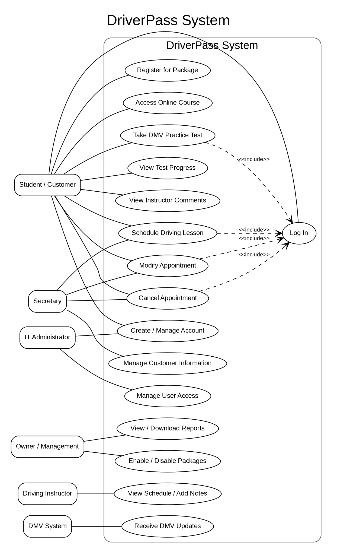

UML Activity Diagrams
Activity Diagram 1: Schedule Driving Lesson
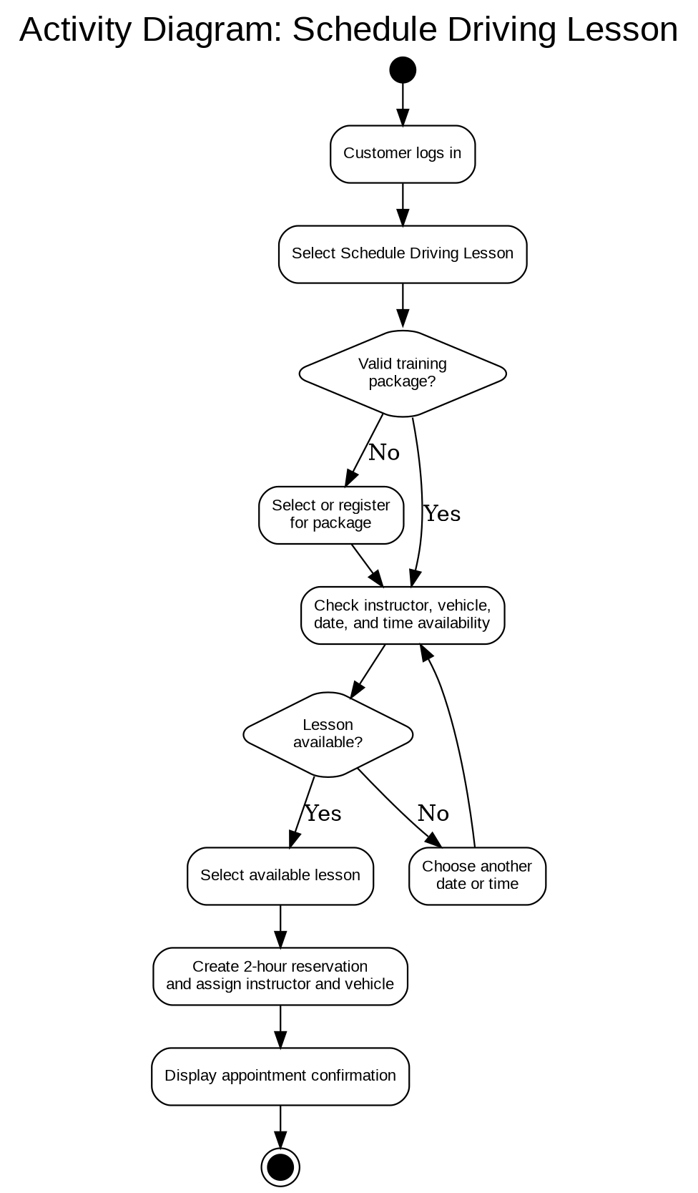
This activity diagram shows how a customer schedules a two-hour driving lesson. The system verifies the customer’s training package, checks instructor and vehicle availability, allows another date or time to be selected when necessary, creates the reservation, and displays a confirmation.

Activity Diagram 2: Take DMV Practice Test
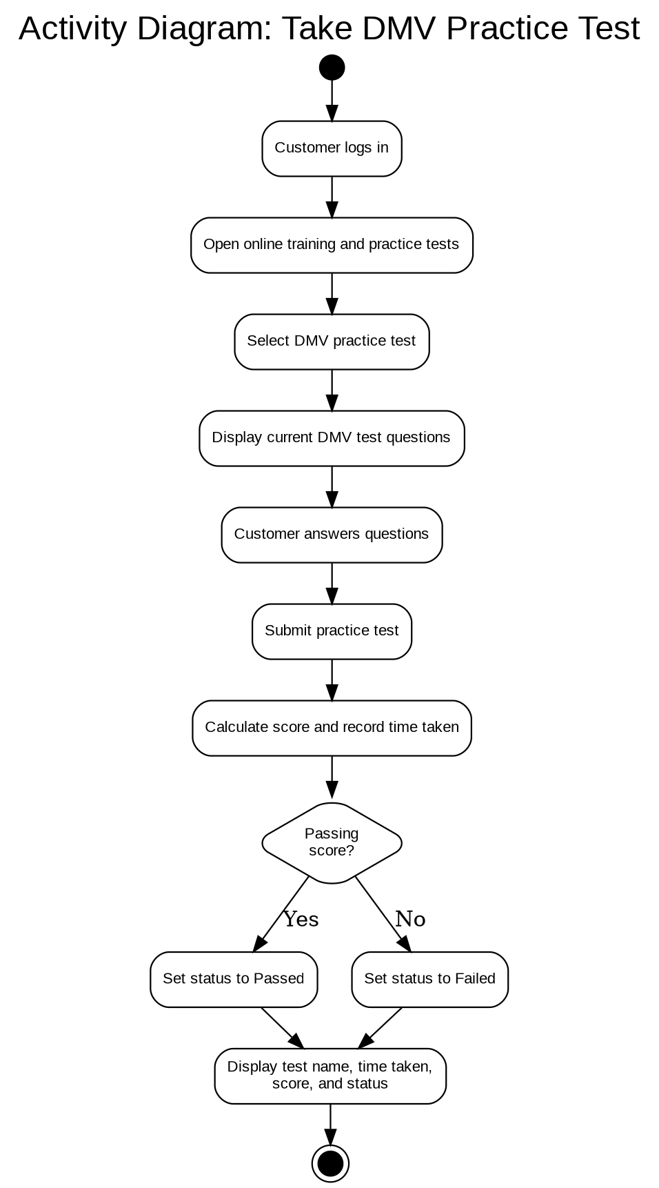
This activity diagram shows how a customer accesses a DMV practice test, completes the questions, submits the test, and receives a recorded result. The system stores the test name, time taken, score, and status.

UML Sequence Diagram
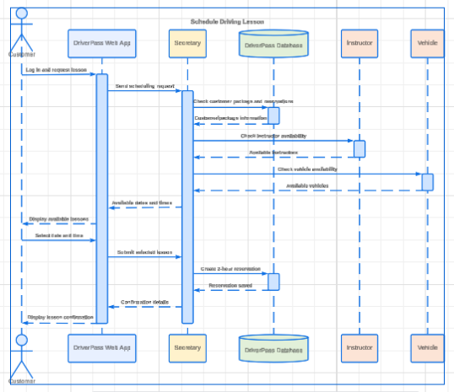
The sequence diagram expands the Schedule Driving Lesson use case and shows the order in which the customer, web application, secretary, database, instructor availability, and vehicle availability interact.

UML Class Diagram

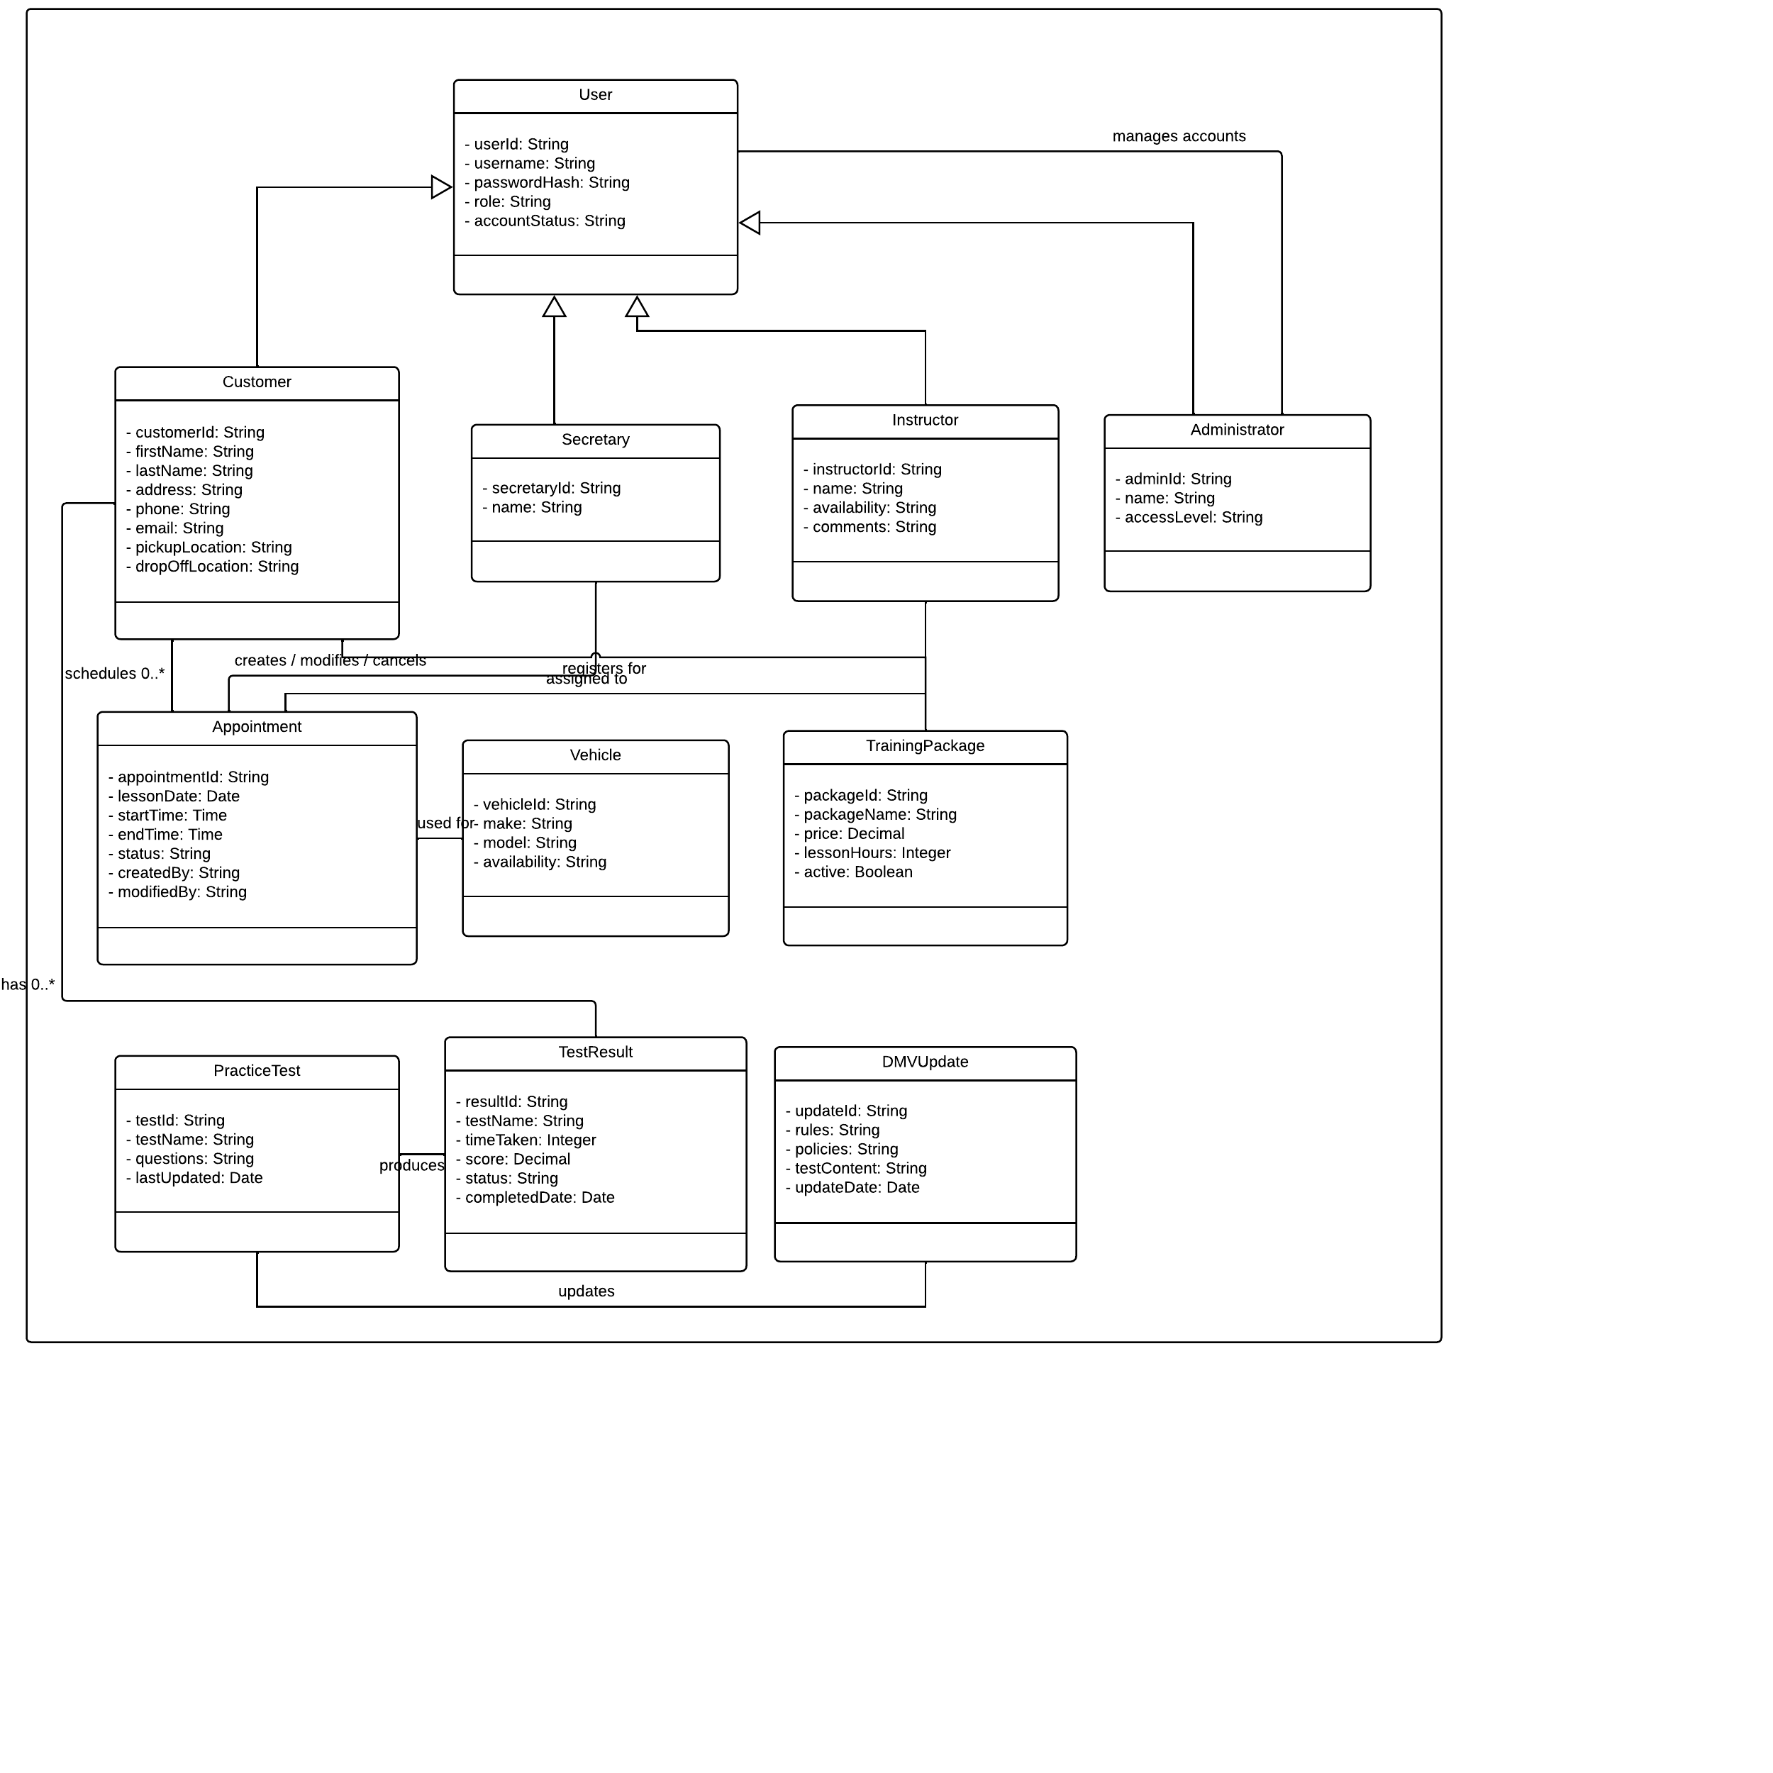

Technical Requirements
Hardware : DriverPass will need cloud-hosted server hardware resources to run the web application and database. Support staff will need computers with internet access (desktops or laptops). DriverPass customers will access the application using computers, tablets and smartphones. The business will need network equipment and reliable internet connectivity.
Software : DriverPass will be a responsive web application using a centralized relational database. DriverPass will need a modern web server/application platform, database management software, and recent versions of web browsers. The web application will allow customers to manage accounts, schedule appointments, take online training lessons, take practice-tests, review reports, and allow administrative staff to update DMV rules/policies/guidelines and upload new practice-test content.
Security : DriverPass will ensure all traffic between the client and server utilize HTTPS with TLS encryption. Users will be required to login with their unique account and will have role-based permissions. Passwords will be stored using proper security standards. Brute force login attempts shall be logged, and investigated by notifying the Administrator. Upon repeated failed login attempts, the account shall be locked temporarily. The system shall restrict access to sensitive customer/payment information.
Infrastructure and Availability : DriverPass application and database shall be deployed in the cloud. This will allow centralized access to the application, easy backups/recovery, and scalability. During normal operation, the system should be available at least 99% of the time. Periodic backups shall be kept to minimize data-loss.
Integration and Data : DriverPass should support importing updated DMV rules/policies-guidelines, updated training lessons, and practice- test content. DriverPass will store customer, driver-instructor, vehicle information, appointments, driving packages, test-results, and audit-log data. Lessons should be scheduled with blocks of two hours where both an instructor and vehicle are available.
Development and Support ToolsDevelopers and Systems Analysts will need access to a source-control system, testing software, a development machine, database administration software, and a CASE tool (such as Lucidchart) to view the system models. Complex updates requiring database and/or application logic changes will need Developer or Systems Analyst intervention (ex. Adding new Modules, Adding new Driving Packages).

